جامعة بوليتكنك فلسطين | 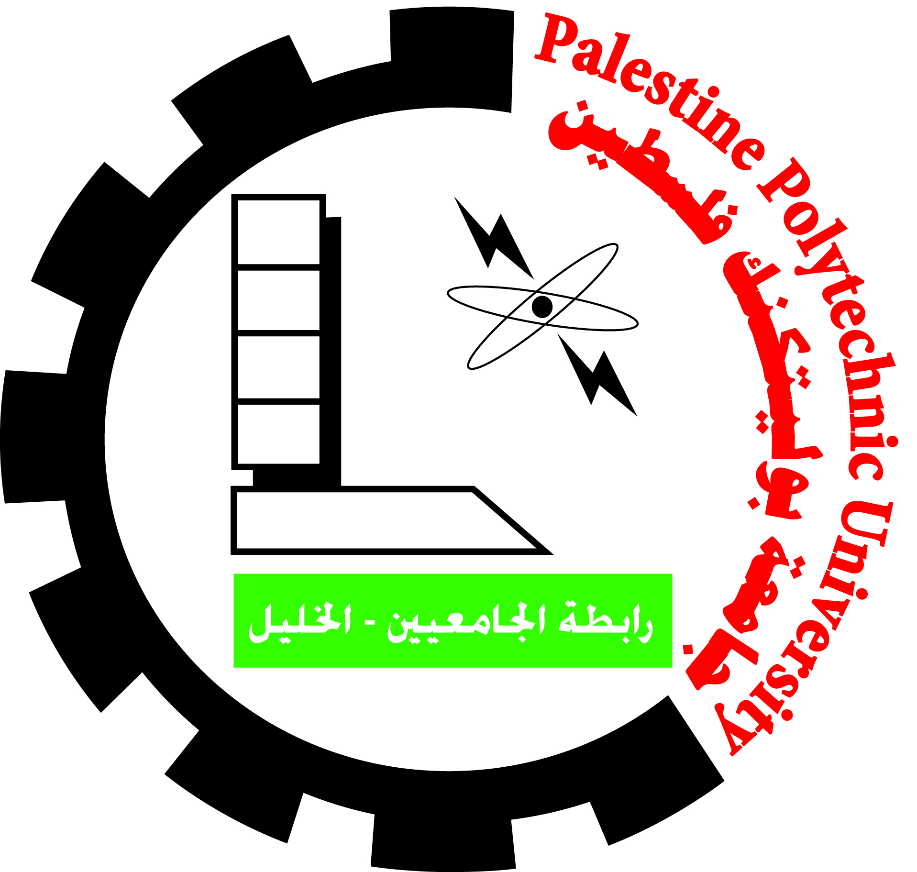 | Palestine Polytechnic University
عمادة الدراسات العليا والبحث العلمي |  | Deanship of Graduate Studies and Scientific Research

جائزة البنك الإسلامي الفلسطيني للبحث العلمي: نموذج تقييم المشاركات

الفئة الرابعة: جائزة غزارة البحث العلمي على مستوى جامعة بوليتكنك فلسطين

- Activities, declaration and classification:

Researcher’s Name :………….

Publishing date |  | Scoring Sheet
Publishing date | Books/ Chapters  (Internat.) | Books/ Chapters  (Locally) | National Conf. | International Conf. | Others | SCOPUS | ISI (SCI, SCIE, SSCI,AHCI) | N & S | Patent and country of registration | Activity Title
 |  |  |  |  |  |  |  |  |  | Number of activities per item: N=

- Activities Scoring
 | Activities ( Number of Activities/item, N) |  |  |  |  |  |  |  |  |  |  | Scoring Sheet
A |  | Books/ Chapters  (Locally) | Books/ Chapters  (Internat.) | National Conf. | International Conf. | Patents and Journal Papers
 |  |  |  |  |  | Other indexing | SCOPUS | ISI (SCI, SCIE, SSCI,AHCI) | N & S | Patents  other | Patents  Reg in PCT countries
 |  | N*8 | N* 10 | N*4 | N* 6 | N*8 | N*12 | N*12 | N*15 | N*10 | N * 15
 |  |  |  |  |  |  |  |  |  |  |  | Total score/item

- Relevance & Fulfillment of Community needs (B):
Fulfillment of Community needs (How much do these activities fulfill the community needs (i.e Impact on the Community)= (B) | 5 | 10 | X 15

Total Score (A+B)

Committee Approval: ……………………./ :………………………………….. / :……………………………………

Date:……………………

